**ROOM RENT WEB APPLICATION WITH ADVANCED FETURES GPS TRACKING SYSTEM**

**by**

**MD RAKIBUL ISLAM**

**ID: 201-15-13996**

This Report Presented in Partial Fulfillment of the Requirements for the Degree of Bachelor of Science in Computer Science and Engineering

Supervised By

**Johora Akter Polin**

Senior Lecturer

Department of CSE

Daffodil International University

Co-Supervised By

**Sharmin Akter**

Senior lecturer

Department of CSE

Daffodil International University



**DAFFODIL INTERNATIONAL UNIVERSITY**

**Dhaka, Bangladesh**

**December 2023**

**APPROVAL**

This Project titled “**Room Rent web Application With GPS Tracking System**”, submitted by **Md Rakibul Islam** ID No: **201-15-13996** to the Department of Computer Science and Engineering, Daffodil International University, has been accepted as satisfactory for the partial fulfillment of the requirements for the degree of B.Sc. in Computer Science and Engineering and approved as to its style and contents. The presentation has been held on January 2024

**Board of Examiners**

**Name Chairman**

**Designation**

Department of CSE

Faculty of Science & Information Technology

Daffodil International University

**Name Internal Examiner**

**Designation**

Department of CSE

Faculty of Science & Information Technology

Daffodil International University

**Name External Examiner**

**Designation**

Department of -------

Jahangirnagar University

**Declaration**

I declare that, this project has been done by us under the supervision of **Johora Akter Polin, Senior** **Lecturer, Department of CSE** Daffodil International University. I also declare that neither this project nor any part of this project has been submitted elsewhere for award of any degree or diploma.

**Supervised by:**



**Johora Akter Polin**

Senior Lecturer

Department of CSE

Daffodil International University

**Co-Supervised by:**

**Sharmin Akter**

Senior lecturer

Department of CSE

Daffodil International University

**Submitted by:**

**Md. Rakibul Islam)**

ID: **201-15-13996**

Department of CSE

Daffodil International University

**ACKNOWLEDGEMENT**

At first i express my heartiest thanks and gratefulness to almighty my God for His divine blessing make me possible to complete the final year project successfully.

I really grateful and wish our profound our indebtedness to **Johora Akter Polin**, **Senior** **Lecturer**, Department of CSE Daffodil International University, Dhaka. Deep Knowledge & keen interest of my supervisor in the field of “Web Application Development” to carry out this project. His endless patience , scholarly guidance ,continual encouragement , constant and energetic supervision , constructive criticism , valuable advice , reading many inferior draft and correcting them at all stage have made it possible to complete of my project.

I would like to express our heartiest gratitude to Professor Dr. Sheak Rashed Haider Noori, andHead**,** Department of CSE, for his kind help to finish our project and also to other faculty member and the staff of CSE department of Daffodil International University.

I would like to thanks our entire course mate in Daffodil International University, who took part in this discuss while completing the course work.

Finally, I must acknowledge with due respect the constant support and patients of our parents.

**Abstract**

In this application Baribazarbd is a Web Application. This application developed by using MERN stack like, React, Node, Express as a database using MongoDB and also used in Bootstrap for responsive. This Application offers users streamlined platform for users to search accommodation post property listing engage with property owners. The Application organized into six distinct categories, catering to wide range of user’s needs. One of the features of this application is its integrated real-time location tracking GPS functionality, that’s enables user to view properties as popup on maps, plan shortest path and locate places to stay efficiently. A user friendly comment section allows to share their opinion on properties. Also offers an impressive properties exploration experience providing with 360 degree image views for a better understanding of the listed rooms on properties. Users can easily share their favorite listing on various social media platforms. User security and authentication are important, with the implementation of JWT tokens and other middleware are used for data security. The app supports both user and publisher roles and allows property owners to manage listings by accepting booking requests and tracking revenue each month through a personalized dashboard. This Application represents an innovative and user friendly solution in the competitive field to property rental and sales platforms. Future enhancements aim to further elevate the Application capabilities and user experience.

**TABLE OF CONTENTS**

|  |  |
| --- | --- |
| **CONTENTS** | **PAGE** |
| Board of examiners | i |
| Declaration | ii |
| Acknowledgements | iii |
| Abstract | iv |
| **CHAPTER** |  |
| **CHAPTER 1: INTRODUCTION** | **1-3** |
| * 1. Introduction | 1 |
| 1.2 Motivation  1.3 Objective  1.4 Expected Outcomes  1.5 Report Layout  **CHAPTER 2: BACKGROUND**  2.1 Introduction  2.2 Related Work  2.3 Scope of the problem  2.4 Challenges  **CHAPTER 3: Requirement Specification**  3.1 Business Process Modeling  3.2 Use Case Modeling and Description  3.3 Activity Diagram  3.4 Design Requirements  **CHAPTER 4: Design Specification**    4.1 Features  4.2 Front-end Design  4.3 Back-end Design | 1  2  2  3  **4**  4  4  4  5  **6-12**  6-9  9  10-12  12  **13-25**  13  14-23  24-25 |
| **CHAPTER 5: Implementation and Testing**  5.1 Requirements for Implementation  5.2 Testing implementation  5.3 Testing approaches  **CHAPTER 6: Conclusion and Future Scope**  6.1 Conclusion  6.2 Future Work and Development  **REFERENCES** | **26**  26  26  27-28  **29**  29  29  **30** |
|  |  |

**LIST OF FIGURES**

|  |  |
| --- | --- |
| **FIGURES** | **PAGE NO** |
| Figure 3.1: Business Process Modeling | 6 |
| Figure 3.2.1: Flow chart | 7 |
| Figure 3.2.2: Data Flow Diagram | 8 |
| Figure 3.2.3: use case model | 9 |
| Figure 3.3.1: Registration & login | 10 |
| Figure 3.3.2: Create post | 11 |
| Figure 3.3.3: UML sequence diagram Booking | 12 |
| Figure 4.2.1: Start page | 14 |
| Figure 4.2.2: Tracker | 14 |
| Figure 4.2.3: User Register | 15 |
| Figure 4.2.4: User Login | 15 |
| Figure 4.2.5: All Ads Page | 16 |
| Figure 4.2.6: Details Page | 16 |
| Figure 4.2.7: Love List Page | 17 |
| Figure 4.2.8: Publisher Login Page | 17 |
| Figure 4.2.9: Publisher Registration Page | 18 |
| Figure 4.2.10: Reset Page | 18 |
| Figure 4.2.11: Publisher OTP Verification Page | 19 |
| Figure 4.2.12: Set New Password Page | 19 |
| Figure 4.2.13: Publisher Dashboard Page | 20 |
| Figure 4.2.14: Publisher Post Page | 20 |
| Figure 4.2.15: Edit Post Page | 21 |
| Figure 4.2.16: Post Page | 21 |
| Figure 4.2.17: Booking Request List Page | 22 |
| Figure 4.2.18: Conformation PDF | 22 |
| Figure 4.2.19: Agreement History Page | 23 |
| Figure 4.2.20: Publisher Profile Update Page | 23 |
| Figure 4.2.21: Mongo Database | 24 |
| Figure 4.2.22: Data Structure | 24 |
| Figure 4.2.23: Photo Library | 25 |
| Figure 4.2.24: Photos and details | 25 |

**CHAPTER 1**

**Introduction**

* 1. **Introduction**

In an era defined by modern transformation the property rental market has undergone a significant shift towards online platforms. My project represents a significant contribution to this evolving landscape offering a feature rich and user-centric room rental web App. The development of app stems from the growing need for a versatile and efficient platform that simplifies the process of searching reliable accommodations and property listings in Bangladesh. Challenges associated with the room rental and sales properties we embarked on a mission to create a comprehensive and intuitive solution that would address the diverse needs of both property seekers and owners. The GPS tracking feature empowers users to explore properties on an interactive map showing shortest route and pinpoint accommodations accurately enhancing their overall search experience. I have used for security rate limiter JWT (Json Web Token) and other most important middleware are included in this web application .My aim to contribute to the continued evolution online property rental solutions while providing a valuable resource for people looking for accommodation in Bangladesh.

* 1. **Motivation**

I was inspired by this project, it is very difficult to find bachelor house or room in our country. Another big challenge for finding home road. The problem resonated with many individuals. Mainly in densely populated urban areas, where finding suitable housing can be a daunting task.

* 1. **Objective**

The objective of this application by builds user friendly solution to address the challenge with finding and sell or rent properties room of any category of our country and navigating the streets of these residence. My dream to build the application to streamline to process and secures rental application to provide a centralized application where user easily access a wide range of properties listings. I also want to help them easily figure out how to get specific place because finding your way in a new area tricky. So create a web application to make every process is simple. The application will have a lots of different categories homes and rooms for rent, user can easily see them all in one place. I want to make sure that every person can use it and understand easily, even add a features that show you exactly where these places are on a map, So Yah you won’t get lost. My aim is helps to every person find reliable places to live without any problems and making it a lots of easier.

* 1. **Expected Outcomes**

The Expected outcome of this project, to create a modern functionalities and user friendly we application, that significantly simple the process of finding rental accommodation for individuals or student in our country. I hope that will attract property owners and publisher to list their accommodations on the platform due to its user-friendly interface and potential for broader visibility. This will contribute to the growth of the platform's property database, providing users with an even wider array of choices. Ultimately, expected outcomes of this project is to create a digital solution that, not only eases the challenges of searching rental accommodation but also brings a positive impression on the rental market in our country.

* 1. **Report Layout**

Chapter 1: I demonstrate about Introduction, Motivation, Objective, and also Expected Outcomes.

Chapter 2: I will be presenting this project scope of the problem and related work.

Chapter 4: I will provide overview design specification, implementation and testing to illustrate both the front and back side design.

Chapter 5: I presented the future development prospects of the project.

Chapter 6: I will elaborate on the conclusion and outline future development scope within the project.

**CHAPTER 2**

**Background**

* 1. **Introduction:**

I have faced by individual seeking rental accommodation in our country. My mission is to simplify all over process of finding reliable rental properties especially for student and job holder. This Application offers a user friendly platform that aggregates a wide range of rental options in one place. Real time location tracking and mapping features will aid users in precisely locating properties and navigating roads. Transparency is a key focus, with detailed property information and user reviews fostering trust within the property rental market.

* 1. **Related Works:**

I extensively researched various archives relevant to this project perspective in Bangladesh. Example: BdTo-Let , THE TOLET , Baribodol , RentalHomeBD , RENTS etc. I build this web application on my own pattern and took some help from above mentioned application. I have thoroughly tested the functionality and their appropriate use. This application is richly equipped with various features.

* 1. **Scope of the problem:**

The primary focus on this project is making a system that can finding suitable rental accommodations in our country making it more accessible for individual living along or students. There will be some scope of problem like:

* When user use GPS tracking system on laptop, he will get low accuracy.
* It has no notification system when user send booking request.
* Set properties location manually on map, Can’t automatically.
  1. **Challenges:**

**i)** **Data Collection:**

Data collection for the BariBazarBd room rental web application posed a multifaceted challenge. A strategic approach to aggregate accurate property information across six different categories, including single room rentals and apartment sales. To address this, a combination of web scraping techniques was employed to extract data from various sources. Additionally, a user-friendly interface has been implemented to encourage users to provide valuable property information, ensuring a comprehensive and reliable dataset.

**ii) Model selection:**

Selecting the appropriate model for the MERN stack was an important decision to ensure smooth functionality and scalability of the BariBazarBd application. The chosen approach involves the benefit of responsiveness for the frontend due to its component-based framework, providing a dynamic and responsive user interface. Node.js and Express are selected for the backend to take advantage of their non-blocking, event-driven architecture, to increase server performance. MongoDB was chosen as the database for its flexibility in handling diverse data structures and seamless integration with Node.js, which contributes to a cohesive and efficient overall model.

**iii) Data Labeling:**

Accurate data labeling, categorization of various features and curating user-generated content in BariBazarBd was accomplished through efficient manual processes and user-friendly tools.

**CHAPTER 3**

**Requirement Specification**

A system's requirements specify what it must do. The criteria specification outlines what

must be accomplished order for the company to achieve its goal.

* 1. **Business Process Modeling :**

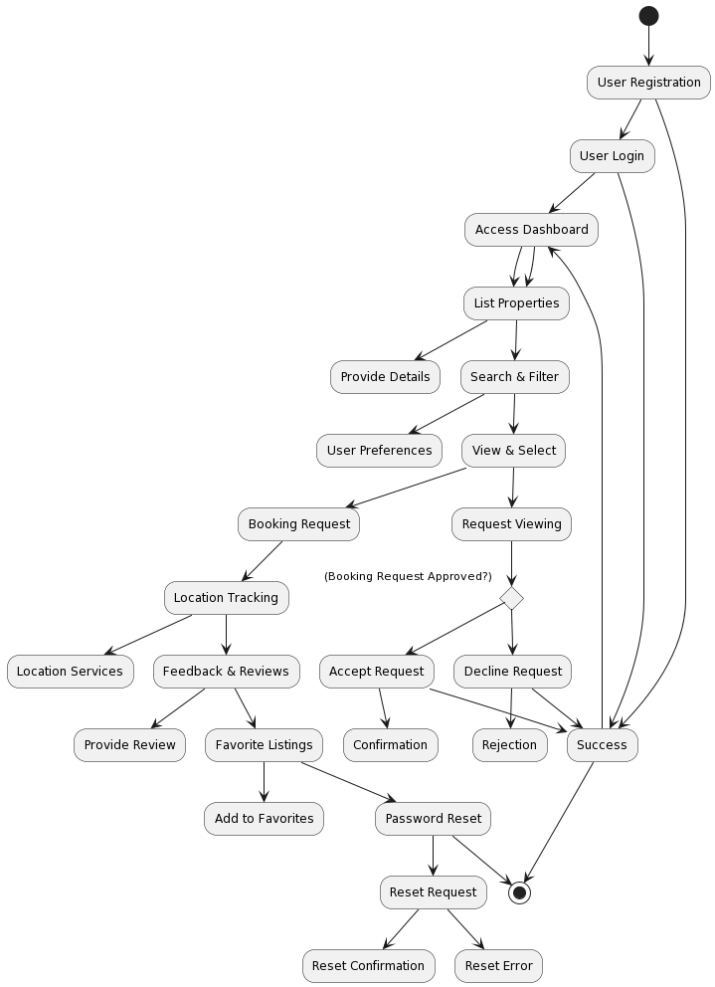

Figure 3.1: Business processing model

It start with user registration and login leading to dashboard access. User can list properties search and make selections. The Booking request point demonstrates a decision making process, where a request is either accepted or declined. The diagram also location tracking feedback and reviews favorite listing and password reset functionality all culminating in a successful outcome or errors.

**Flowchart:**

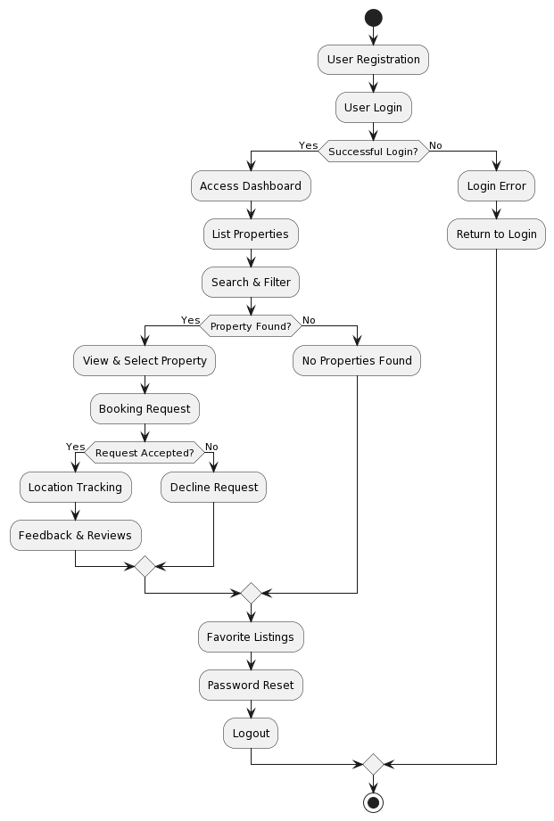

Figure 3.2.1: Flow chart for system

It start with user registration and login with a decision point checking for successful login. If it successful user access to the dashboard where they can list properties search and filter. The flowchart accommodation property availability enabling users view select and make booking request. User can still explore favorite listing reset their passwords or log out, in case of login errors users can return to the login process.

**Dataflow Diagram:**

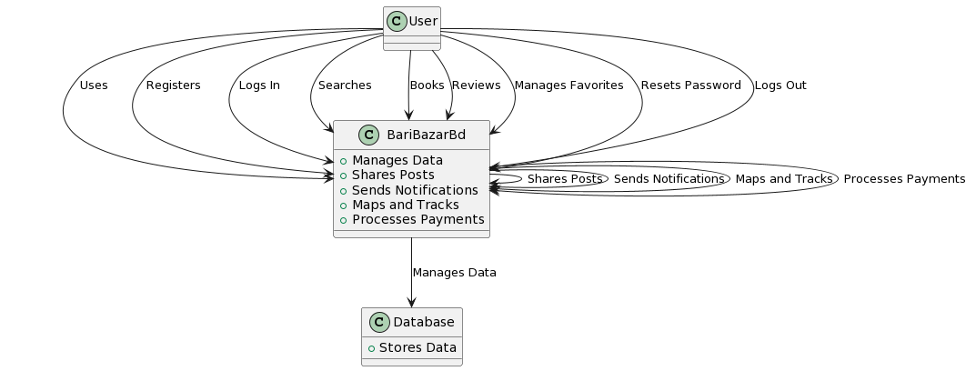

Figure 3.2.2: Data Flow Diagram for System

This program necessitates a very basic configuration for smooth operation.

Configuration of hardware required:

This web application requires registration for users, and publisher to post

and user comment from his experience.

Configuration of software is needed :

• Application: Web site (web-based)

• Tool: Visual studio,Notepad

• Front in design: React.js , React-bootstrap

• Back end design: Node js, Express.js

• Database: MongoDB

It also specifies the specifications that must be met:

• Data accuracy

• Efficiency of working

• Real-time data show

• User friendly

• Effective

* 1. **Use Case Modeling and Description**



Figure 3.2.3: use case model

It depict ‘user’ and ‘publisher’ actor and show the use case associated with each. Users can perform actions like registration login and property related activities while publisher have use case for property management and statistics. This diagram offers a clear view of user-system interactions and the roles of different actors within the project.

* 1. **Activity Diagram**
     1. **Registration & login**

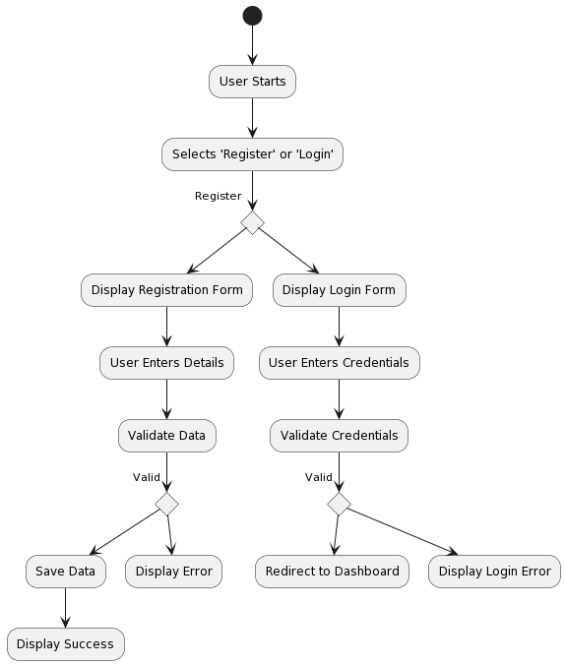

Figure: Registration & login

User start by choosing either Register or login leading to the display of the respective from data validation and response based on the validity of input either leading to data saving and success messages or displaying errors and login redirection.

* + 1. **Create Post**

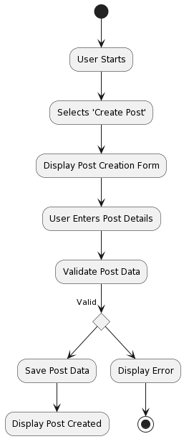

Figure: Create post

Users begin by selecting create post leading to the display of a post creation form user data input and validating if the input valid the post data is saved resulting in a post created message otherwise an error is displayed.

* + 1. **Booking Request and Accept**

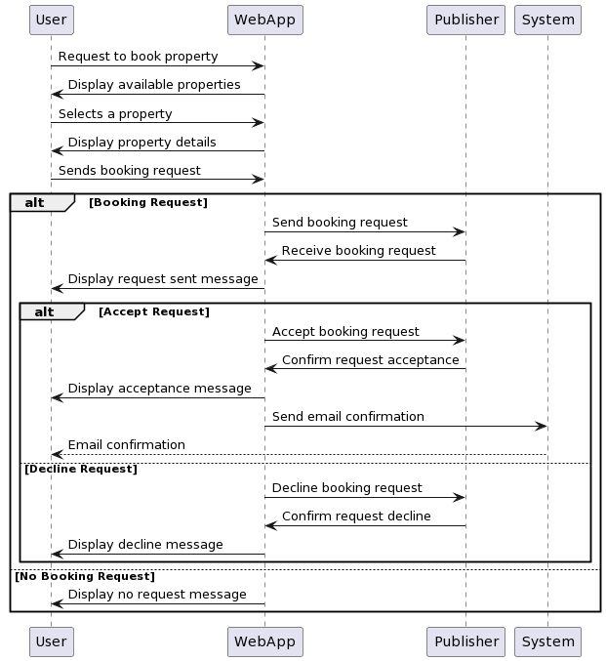

Figure: UML sequence diagram Booking

It includes interactions with the web application, property selection, request transmission to the publisher, and two possible outcomes: acceptance with email confirmation or decline with a message to the user. In the absence of a booking request, a "No Booking Request" message is displayed to the user.

* 1. **Design Requirements**

System design includes the description of a system's architecture, components, modules, interfaces, and data to align with specific requirements. The overall system design of our application is shown in this chapter, which includes a processing model, flow map, use case , activity, and also data flow diagram. There is a user-friendly design. If time permits, some kind of edit would be allowed in the future.

**CHAPTER 4**

**Design Specification**

**4.1 Features**

* Show location on map as popup
* Real-time location tracking
* Different Categories
* User registration and login
* Location search and price filter
* 360 degree view
* Favorite listing
* Share
* Comments
* Publisher registration and login
* Forget password
* Dashboard
* Booking Listing
* Post
* Booking conformation Mail
* Booking conformation clearance (pdf)
* Logout

**4.2 Front-end Design**

**4.2.1 Start page**

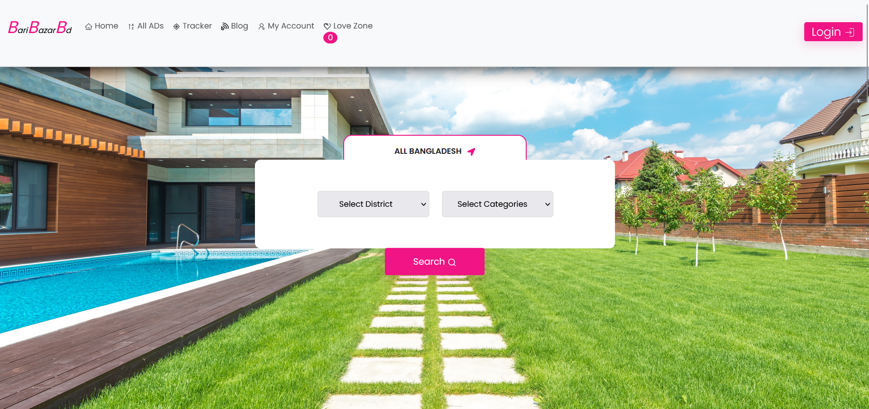

Figure 4.2.1: Start page

**4.2.2 Tracker**

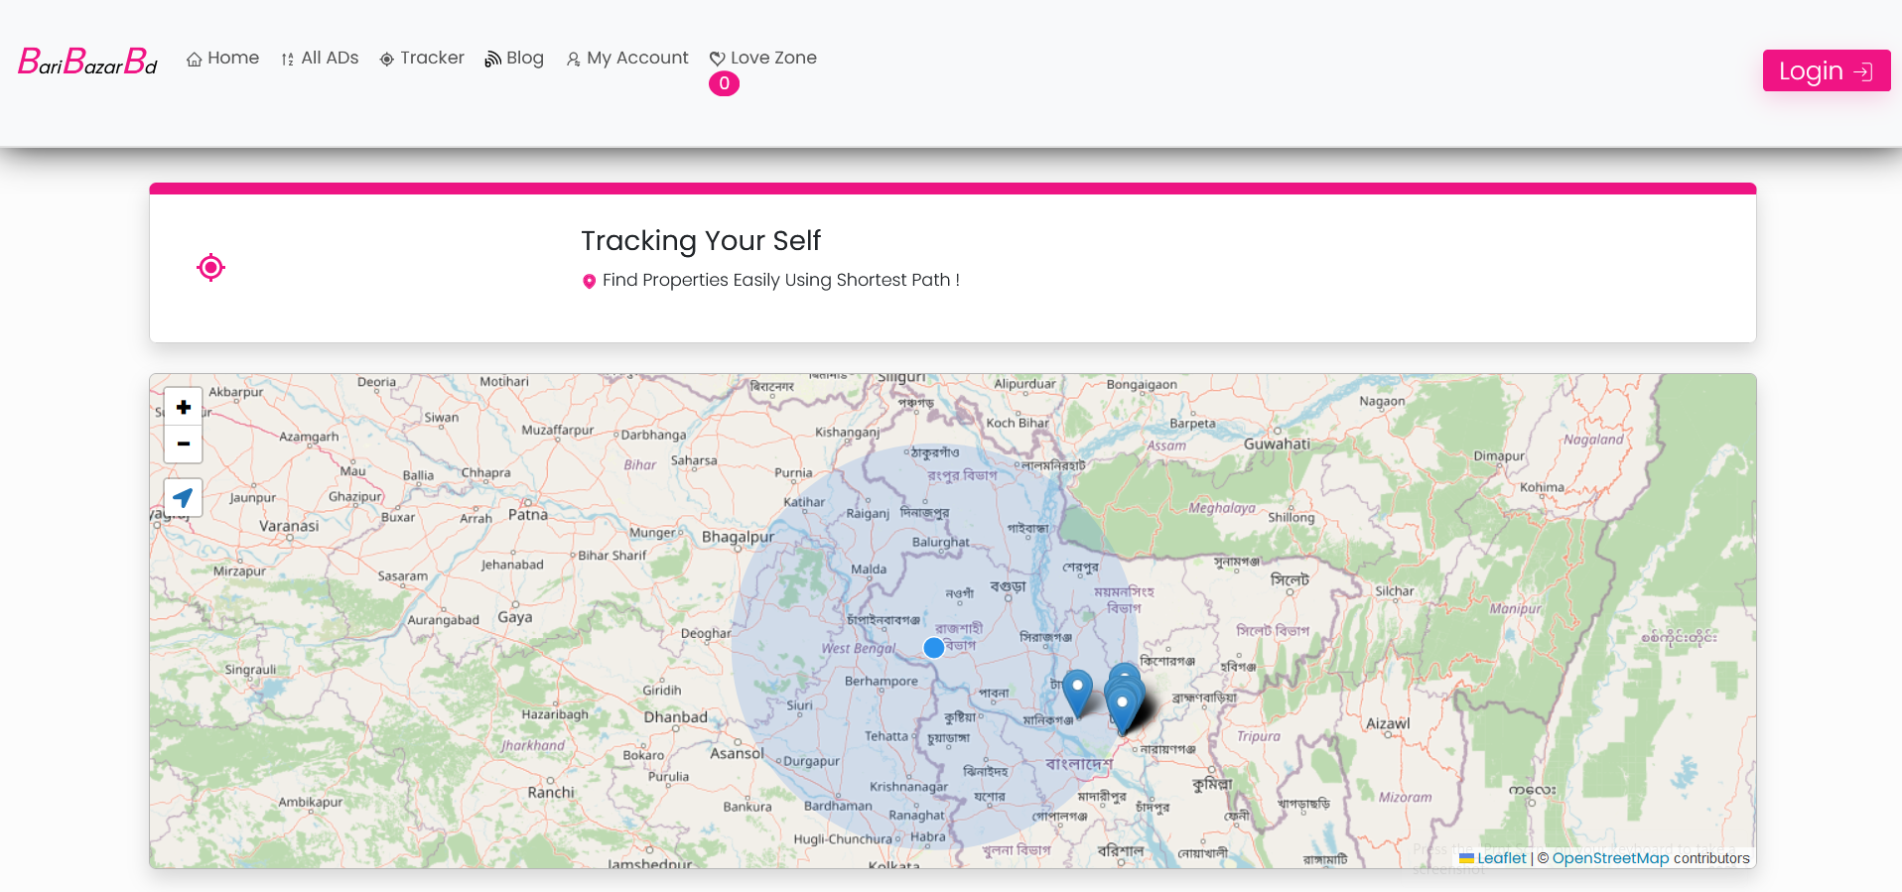

Figure 4.2.2: Tracker

**4.2.3 User Register**

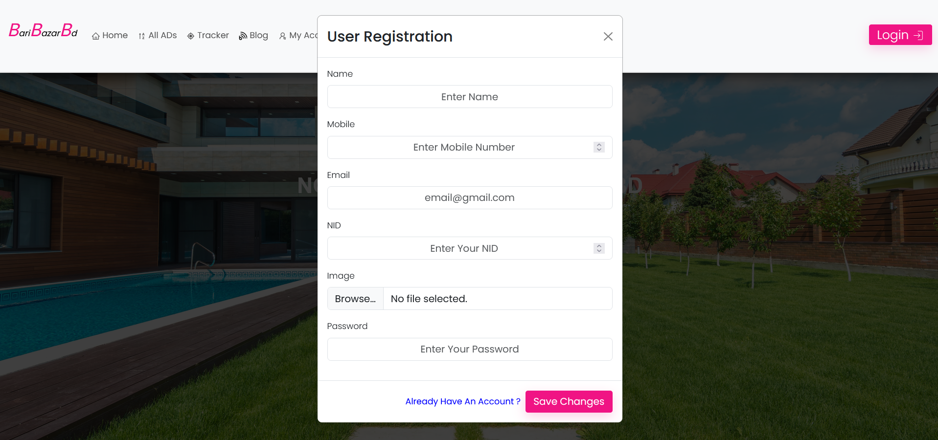

Figure 4.2.3: User Register

**4.2.4 User Login**

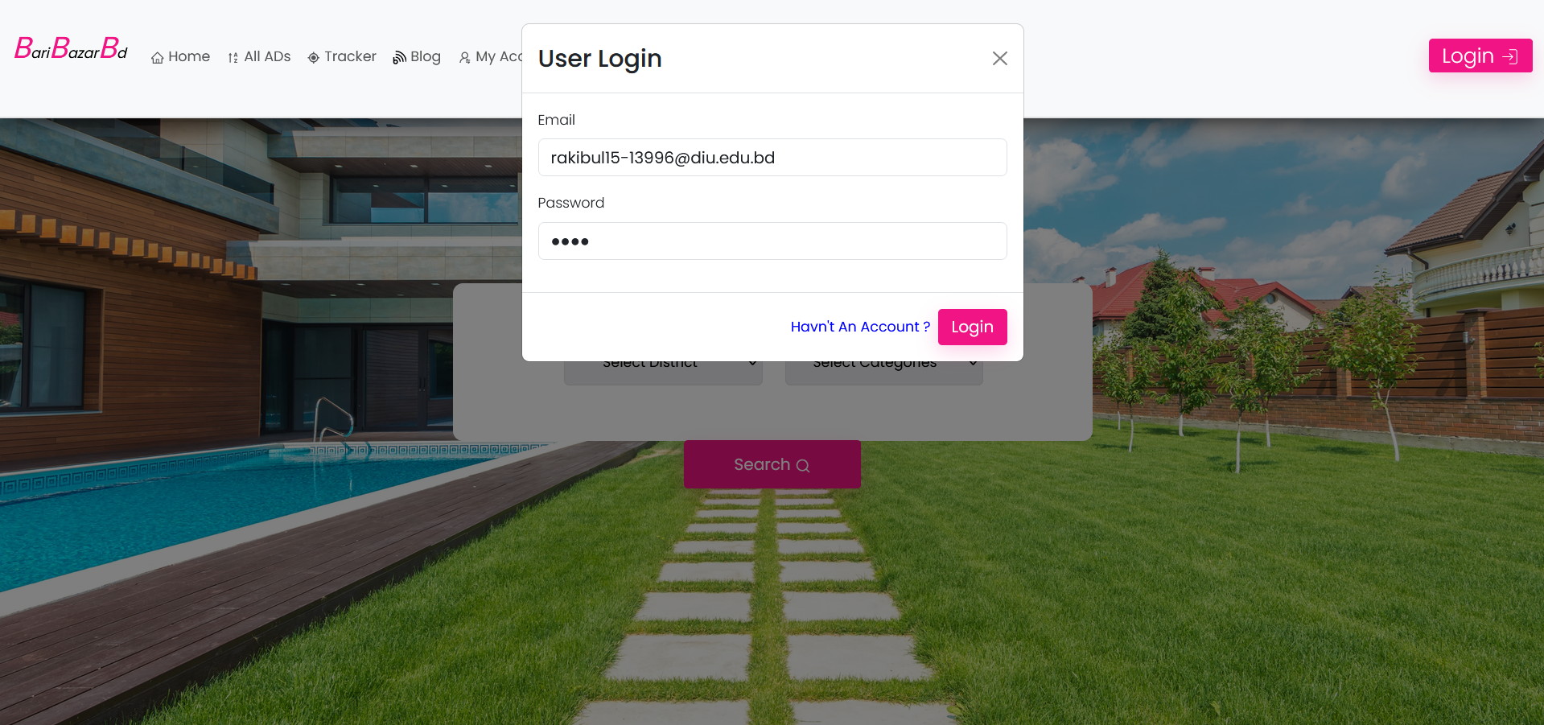

Figure 4.2.4: User Login

**4.2.5 All Ads Page**

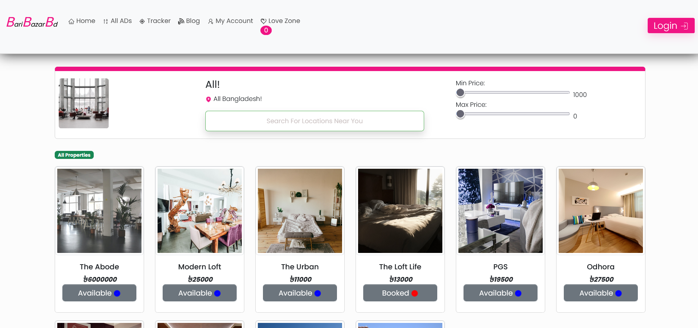

Figure 4.2.5: All Ads Page

**4.2.6 Details Page**

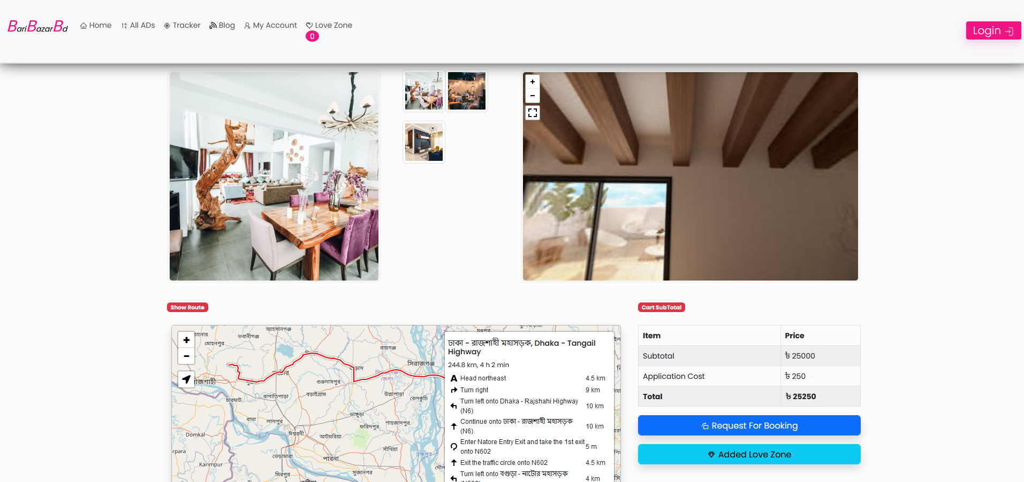

Figure 4.2.6: Details Page

**4.2.7 Love List Page**

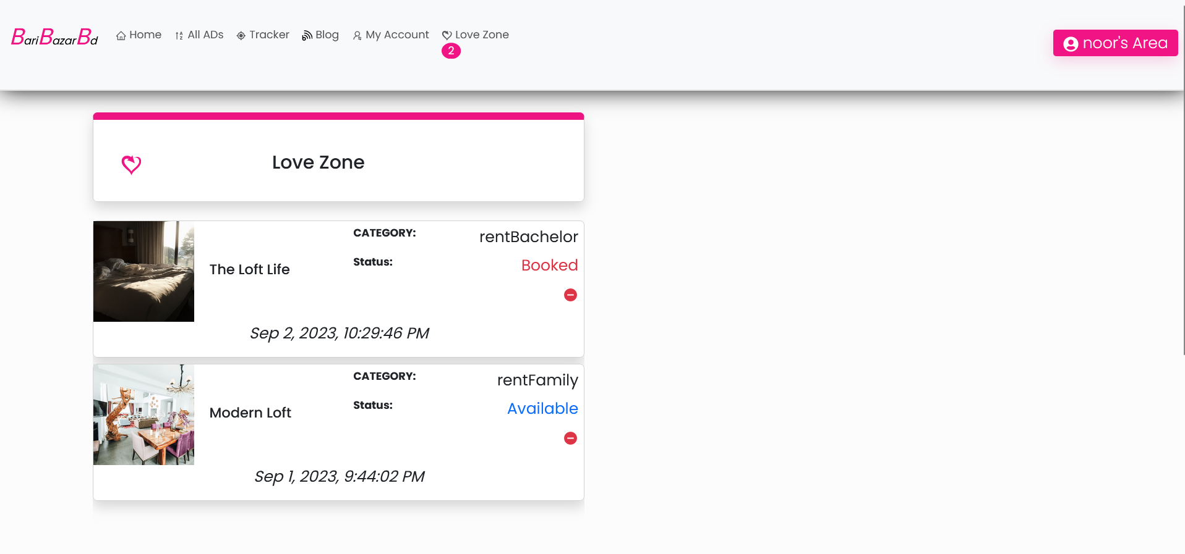

Figure 4.2.7: Love List Page

**4.2.8 Publisher Login Page**

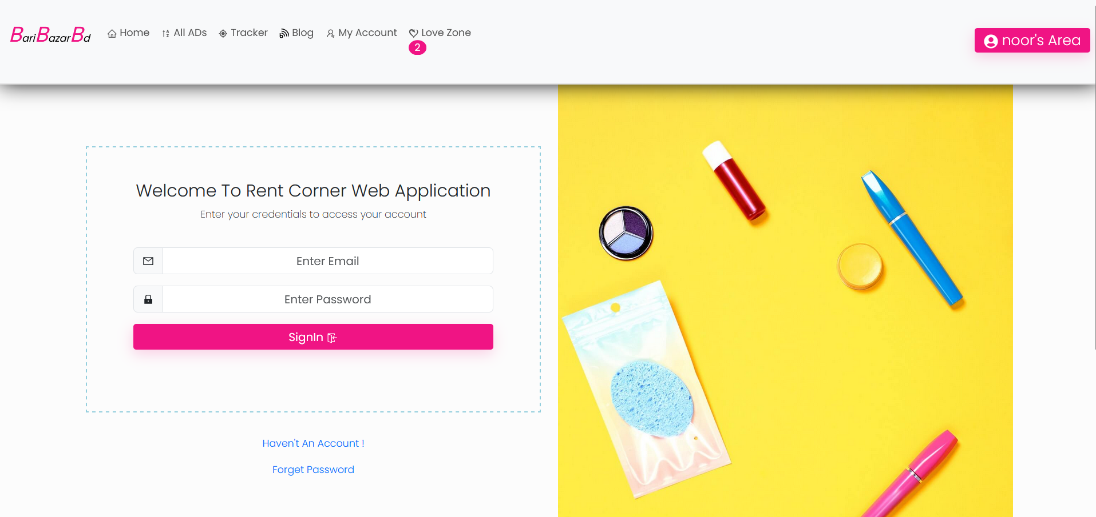

Figure 4.2.8: Publisher Login Page

**4.2.9 Publisher Registration Page**

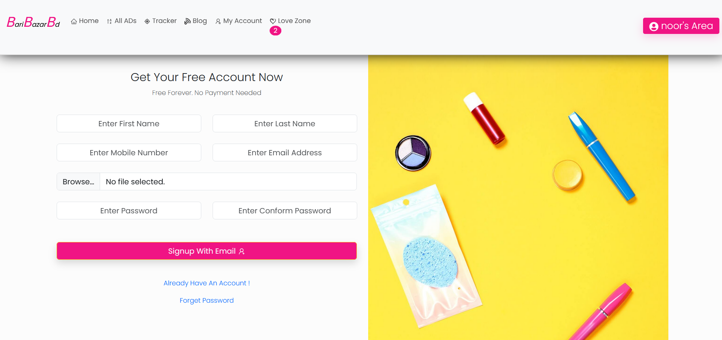

Figure 4.2.9: Publisher Registration Page

**4.2.10 Reset Password Page**

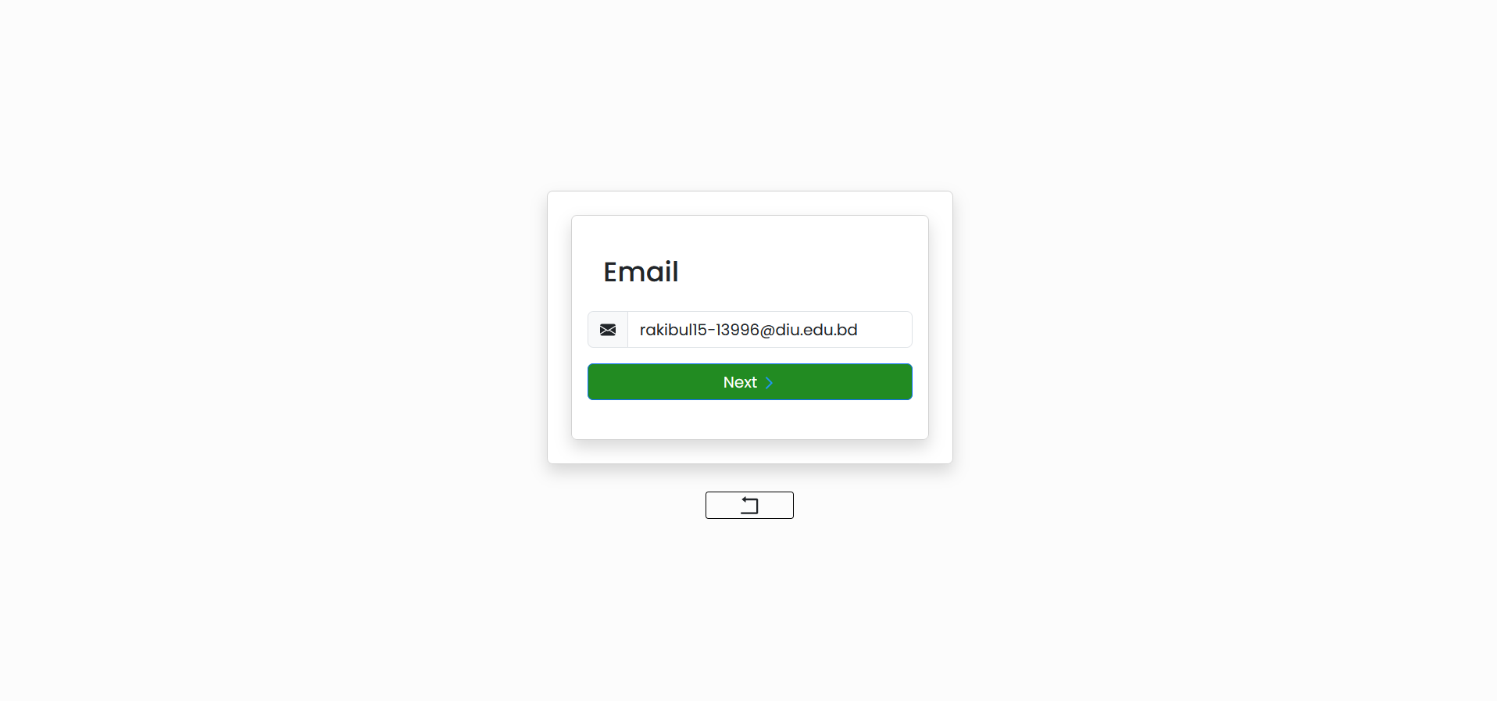

Figure 4.2.10: Reset Page

**4.2.11 OTP Verification Page**

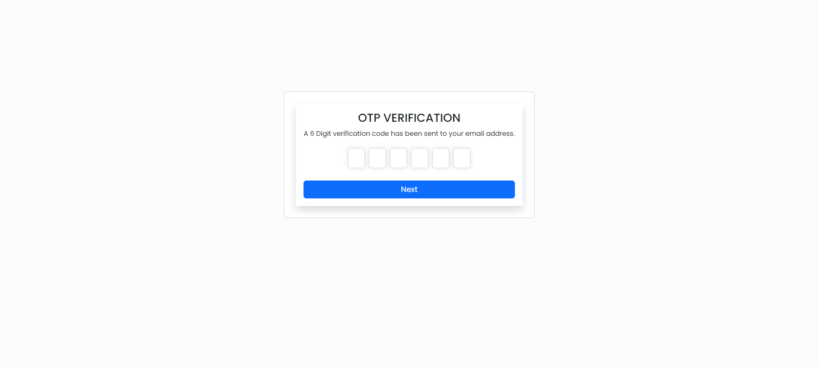

Figure 4.2.11: Publisher OTP Verification Page

**4.2.12 Set New Password Page**

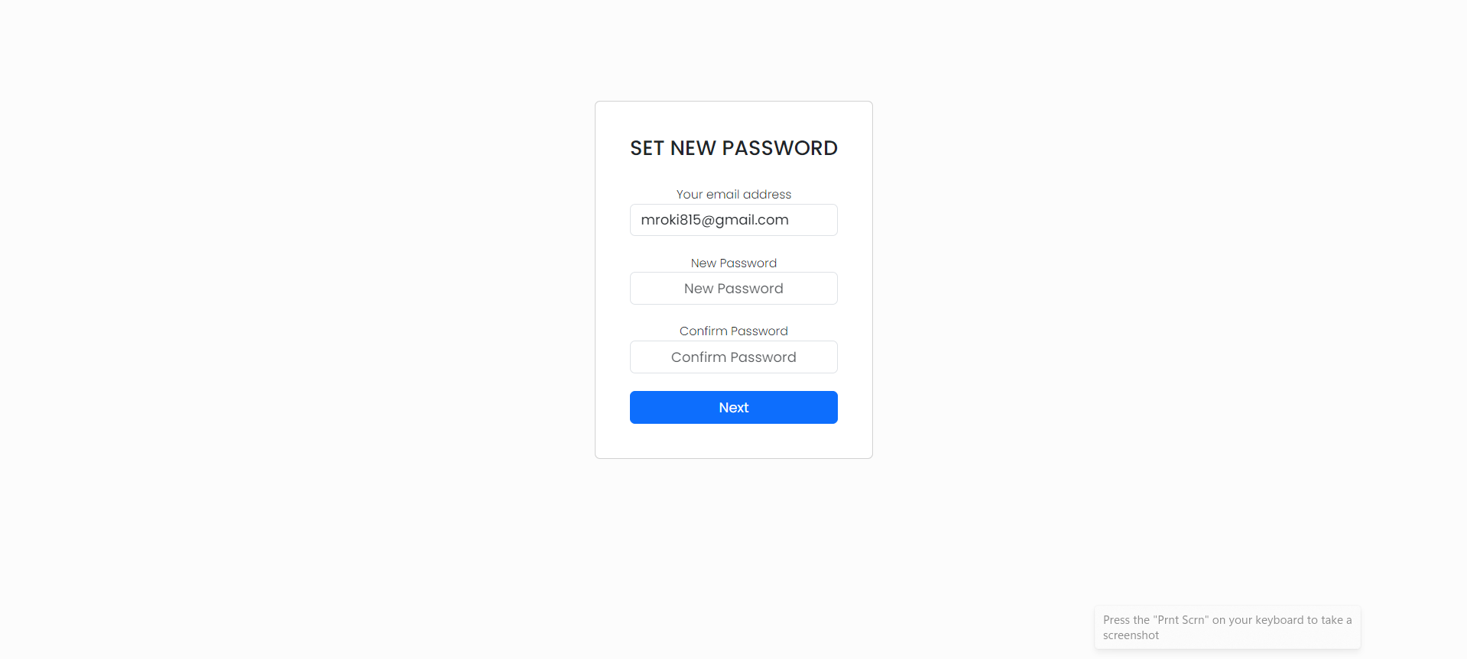

Figure 4.2.12: Set New Password Page

**4.2.13 Publisher Dashboard Page**

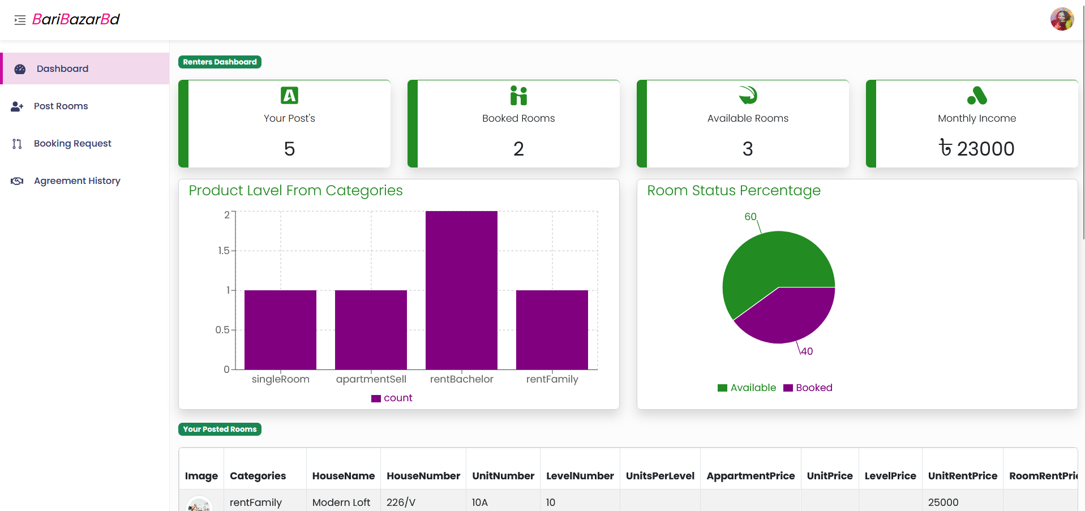

Figure 4.2.13: Publisher Dashboard Page

**4.2.14 Publisher Post**

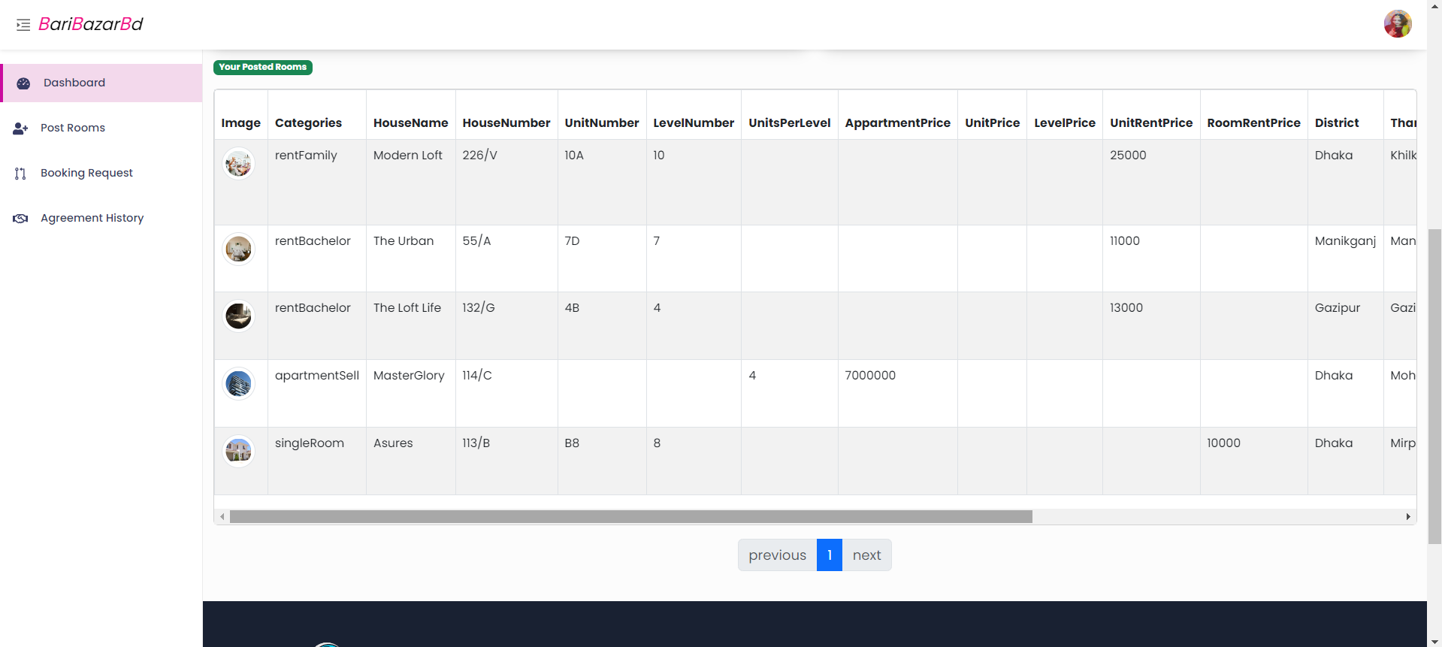

Figure 4.2.14: Publisher Post Page

**4.2.15 Edit Post**

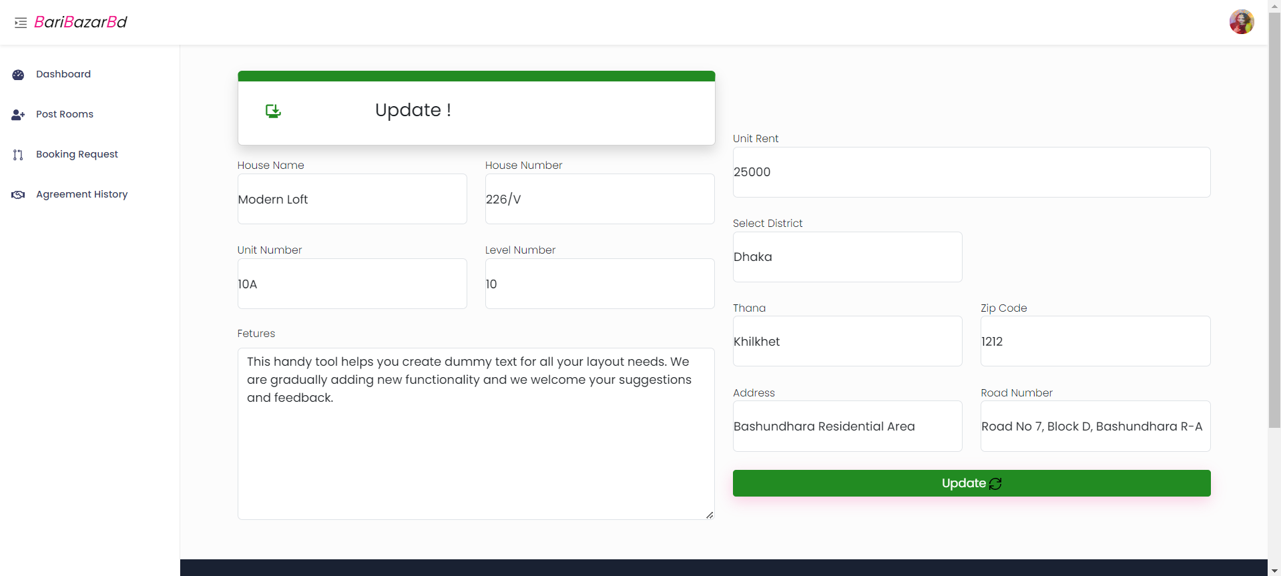

Figure 4.2.15: Edit Post Page

**4.2.16 Post Page**

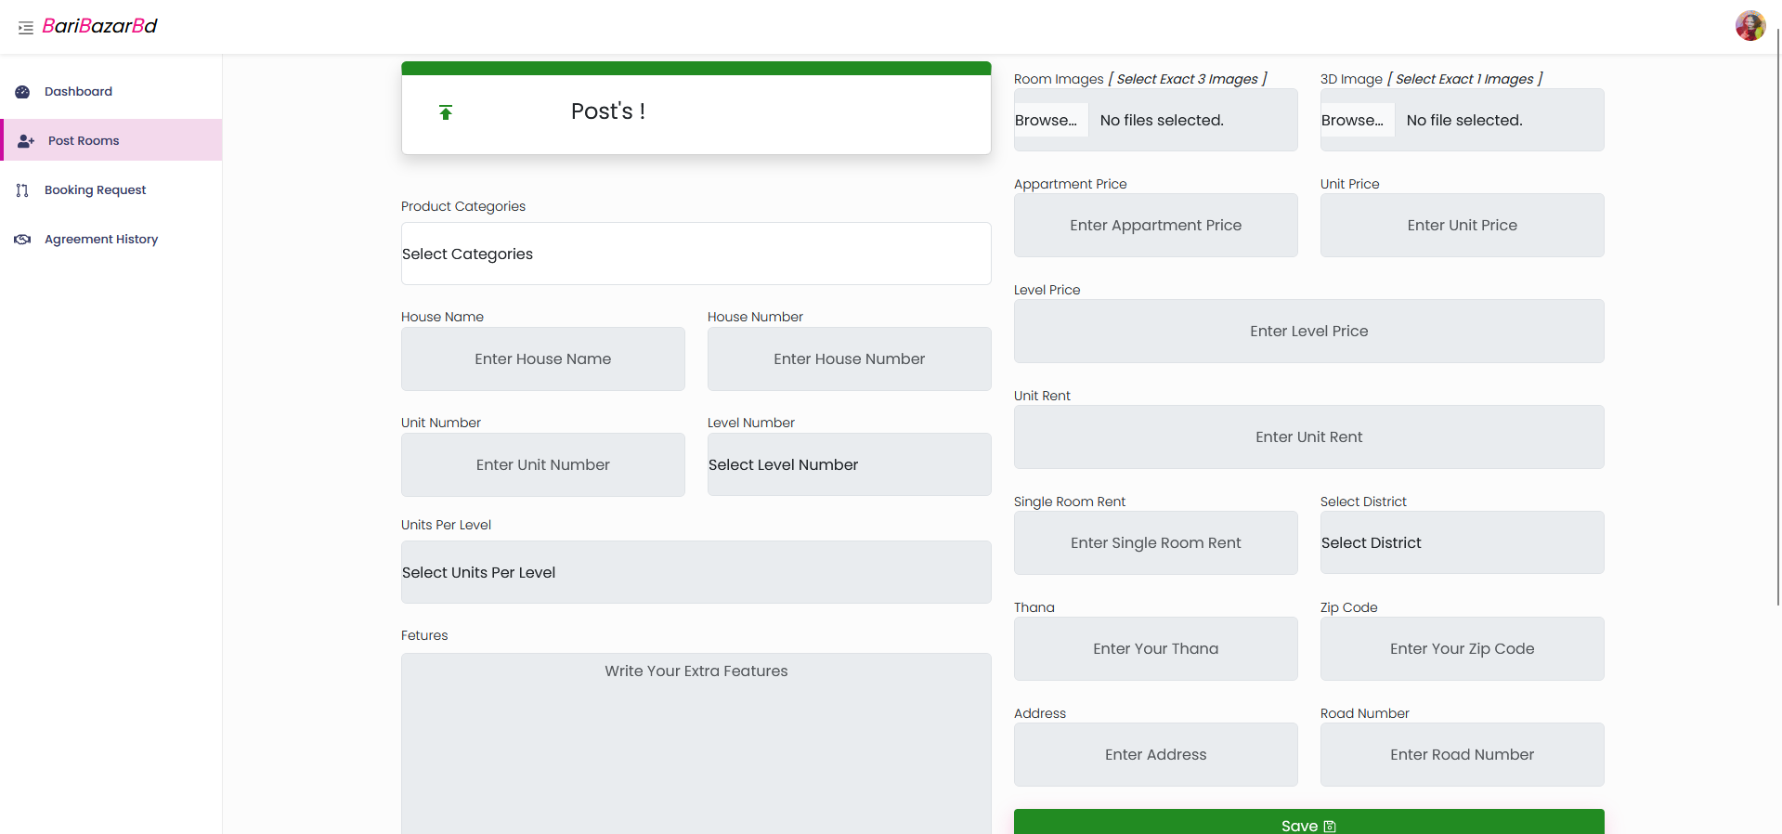

Figure 4.2.16: Post Page

**4.2.17 Booking Request List Page**

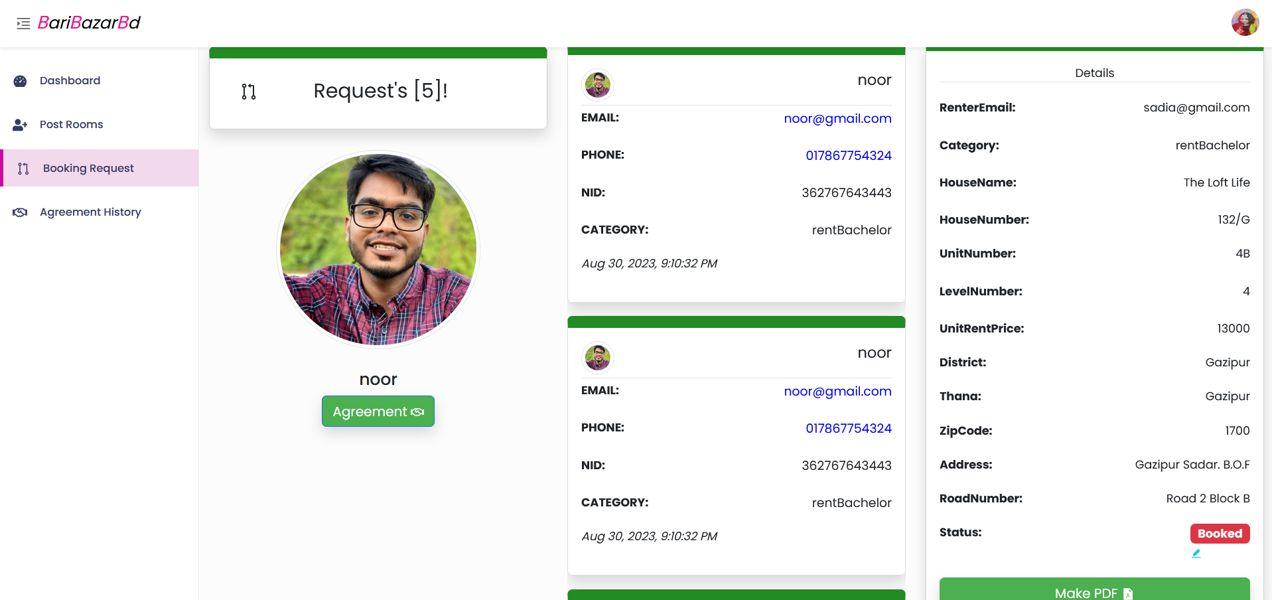

Figure 4.2.17: Booking Request List Page

**4.2.18 Conformation PDF**

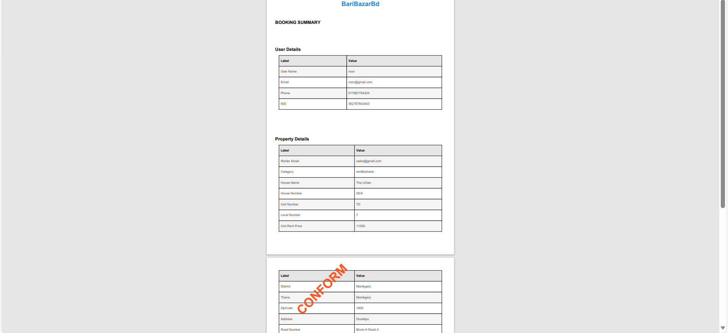

Figure 4.2.18: Conformation PDF

**4.2.19 Agreement History Page**

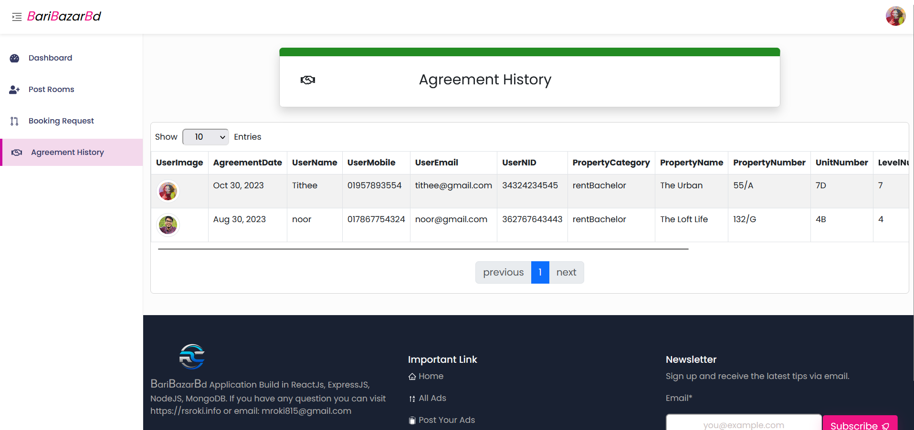

Figure 4.2.19: Agreement History Page

**4.2.20 Publisher Profile Update Page**

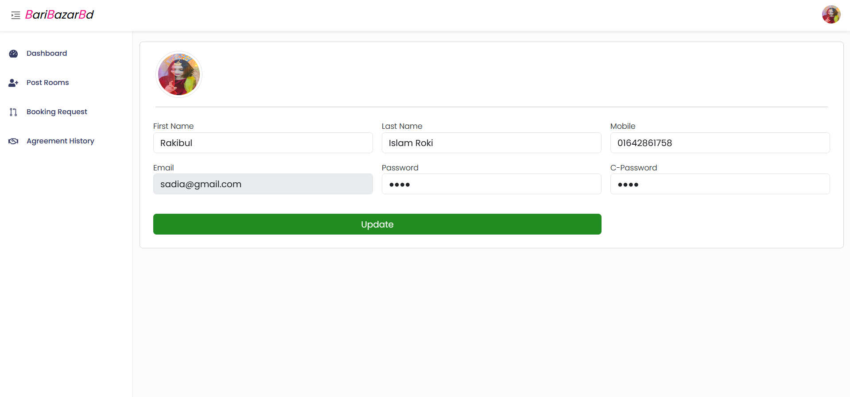

Figure 4.2.20: Publisher Profile Update Page

**4.3 Back-end Design**

**4.3.1 Mongo Database**

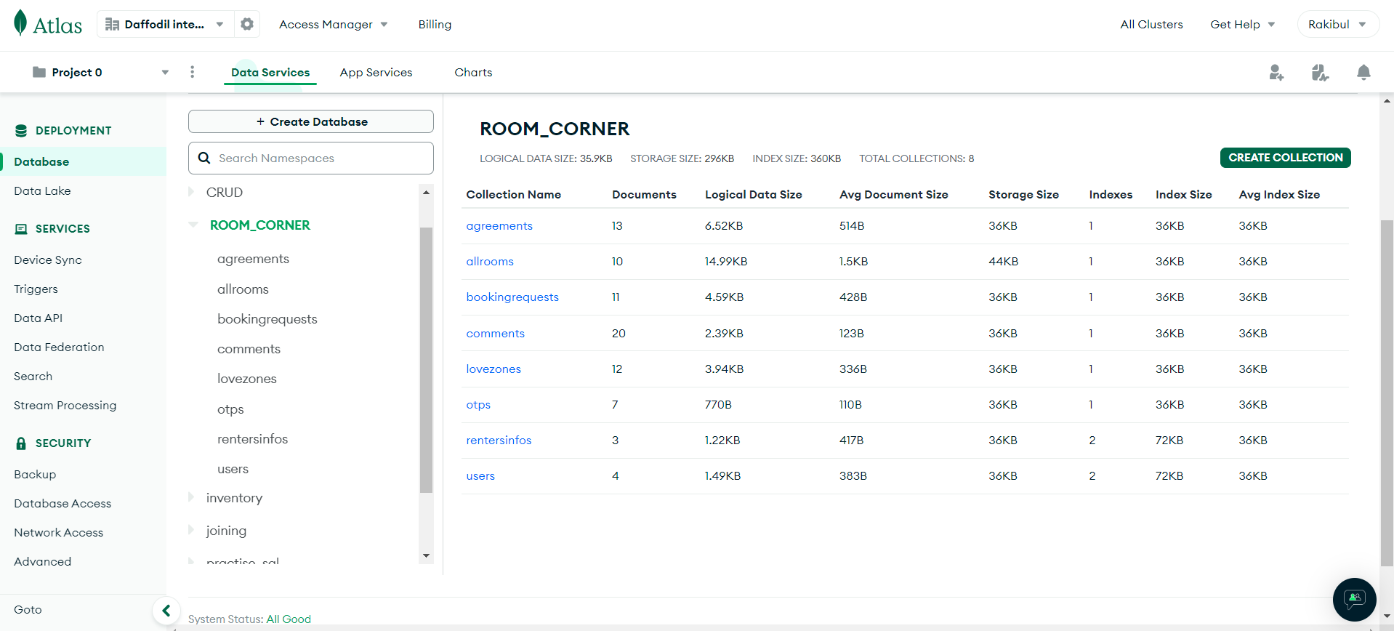

Figure 4.3.1: Mongo Database

**4.3.2 Data Structure**

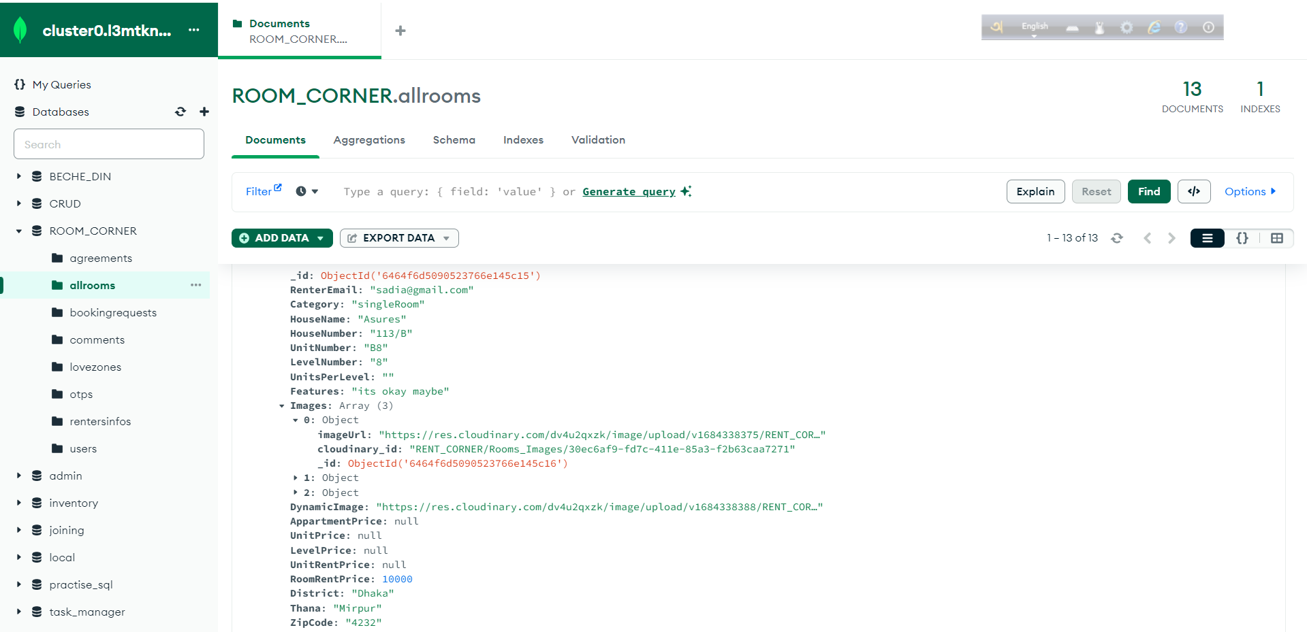

Figure 4.3.2: Data Structure

**4.3.3 Photo Library Structure**

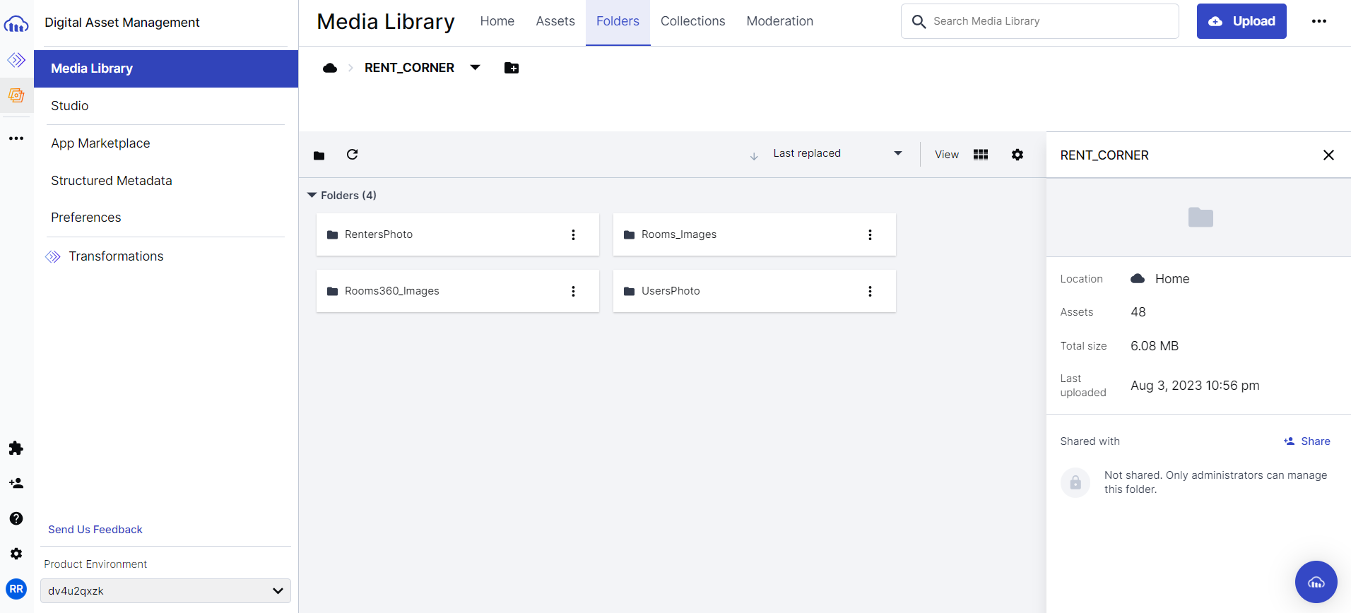

Figure 4.3.3: Photo Library

**4.3.4 Photos And Details**

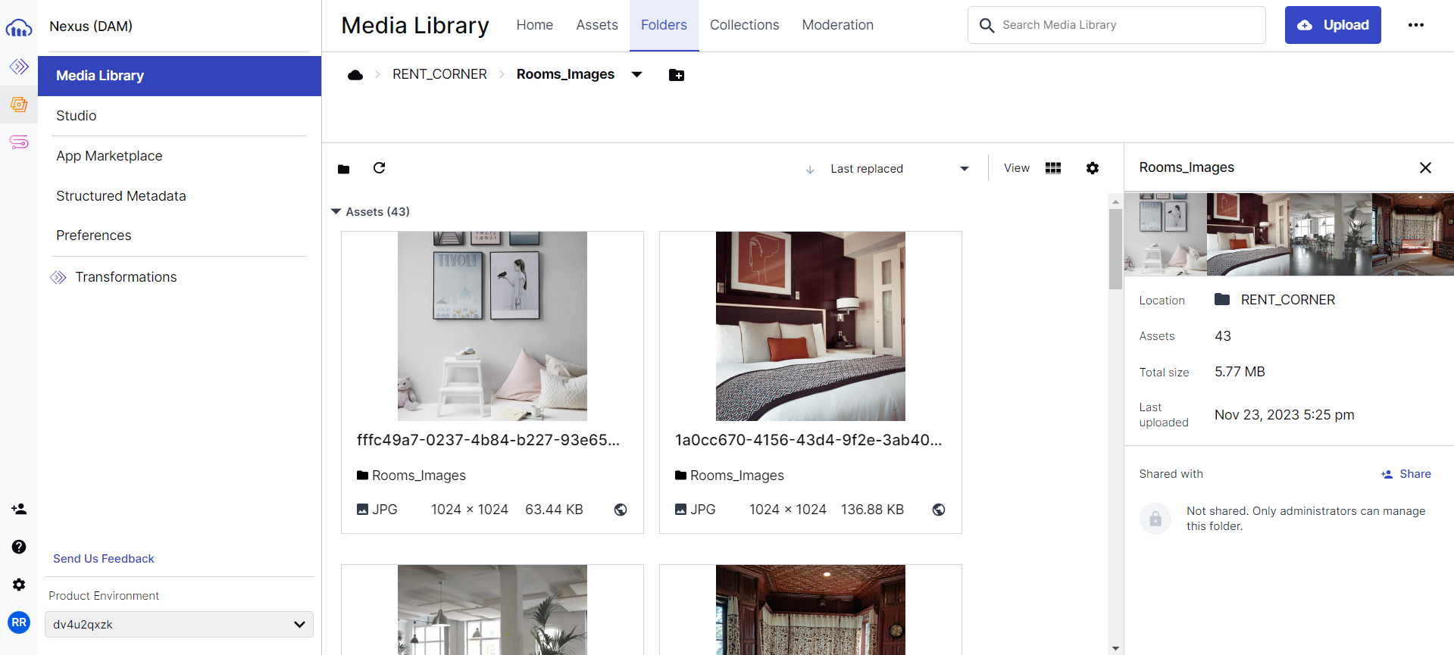

Figure 4.3.4: Photos and details

**CHAPTER 5**

**Implementation and Testing**

**5.1 Requirements for implementation**

In this section I will showcase all of the components and functions that and utilized to finalize my web application.

* The back end is built with Node js , Express js .
* Mongo DB is my real-time database.
* For validation I use JavaScript.
* An error message appears if the input is invalid.
* For icon design, use React-icons.

**5.2 Testing implementation**

Implementation Testing involves the process of thoroughly testing all of a system's procedures, during which the tester or system device can discuss cases and parameters to ensure that the system is reliable. The method of implementation testing is as follows:

**Front-end design:** React and React-Bootstrap for responsive are used in my front-end development.

**Back-end development:** Use Node and Express, as well as Mongo DB, are used to build in my backend.

**Project type:** Website

**Project Language:** English

I have use a variety of roles, resources, and equipment to carry out this project, all of which

Aid in the peaceful development of my project.

**5.3 Testing approaches**

Testing approaches for your BariBazarBd app should encompass various levels and types of testing to ensure its functionality, performance, and security. Here are tailored testing approaches for your room rental web application:

**1. Unit Testing:**

Objective: Verify the correctness of individual components, such as functions, API endpoints, and database interactions.

Implementation: Use testing frameworks like Jest or Mocha to automate the testing of specific functions and modules within the application.

**2. Integration Testing:**

Objective: Ensure seamless interactions between different modules, such as frontend and backend components, database connections, and external APIs.

Implementation: Employ tools like Super test or Cypress for end-to-end testing to validate the integration of various application components.

**3. Functional Testing:**

Objective: Validate the overall functionality of the BariBazarBd app, including features like property search, real-time location tracking, booking requests, and user interactions.

Implementation: Perform comprehensive functional testing using test cases that cover all user scenarios and features.

**4. Performance Testing:**

Objective: Assess the app's performance under various conditions, especially during peak usage times.

Implementation: Use tools like Apache JMeter or Gatling to simulate user traffic and measure response times, scalability, and resource usage.

**5. Beta Testing:**

Objective: Gather valuable feedback from a select group of real users to assess functionality, usability, and overall performance before the official release.

Implementation: Release a stable beta version to a controlled group, collect user feedback, address reported issues, and ensure readiness for the broader audience.

Tailoring these testing approaches to the specific features and functionalities of BariBazarBd will help ensure a robust and reliable web application for room rentals

**CHAPTER 6**

**Conclusion and Future Scope**

**6.1 Conclusion**

In this application I’ve tackled the common problem of finding properties in our Bangladesh. My user friendly platform offers easy properties discovery GPS tracking social media sharing and direct booking system. This application is solution that simplify property rental focus on the user experience and meeting real world challenges. My aim is to simplify and enhance the overall user experience.

**6.2 Future Work and Future Development**

Every web application has a set of advantages and disadvantages. It depends on how a Project is put together. The user's work and public demand will guide the development of this project. I will attempt to develop an android version of this project in the future, even though it is a web-based website. Implementing machine learning algorithm, user can input their furniture’s details and algorithm suggest the room or property size that accommodates their furnishings. Integrating secure payment system for transaction within the platform for booking process smoother. Creating a community aspect within the platform where user and publisher can interact share tips and seek advice.

**REFERENCES**

1. React.js, ava ilable at << https://legacy.reactjs.org/docs/getting-started.html >>, last accessed on 09-09-2023 12.00am
2. Node.js, available at << https://nodejs.org/en/docs >>, last accessed on 09-10-2023 7.00pm
3. MongoDB, available at << https://www.mongodb.com/docs/ >>, last accessed on 05-08-2023 11.00pm
4. Express.js, available at << https://expressjs.com/en/5x/api.html >>, last accessed on 8-06-2023 11.00pm
5. Bootstrap, available at<<https://getbootstrap.com/docs/5.0/getting-started/introduction/ >>, last accessed on 17-04-2023 10.00am

1. CSS, available at << https://www.w3schools.com/cssref/index.php>>, last accessed on 20-02-203 8.00pm
2. country living, available at << https://www.countryliving.com/gardening/>>, last accessed on 11-11-2023 6.00 pm
3. gardening knowhow, available at <<https://www.gardeningknowhow.com/garden-how-to>>, last accessed on 11-11-2023 8.00pm

